ISP connectivity options

ISP services

**Internet service provider** (ISP)

**It provides the link between home network and the internet**

They are critical for global internet each IPS is connected to other ISPs

They are connected in hierarchical manner

**The prime medium that connect them is fiber-optic cable**

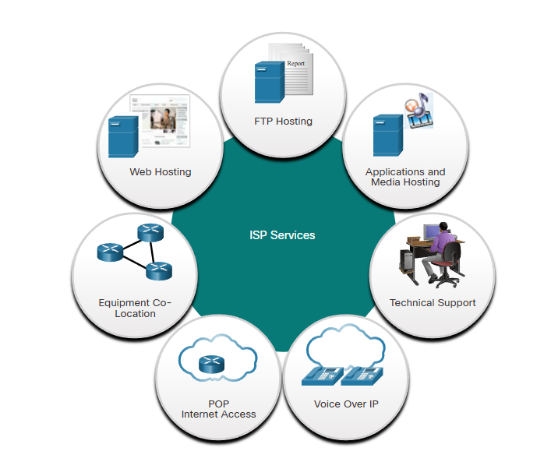

ISP connections

The interconnection of ISPs forms the **backbone of the internet is a complex web of fiber- optic cables with networking switches and routers that direct the flow if information**

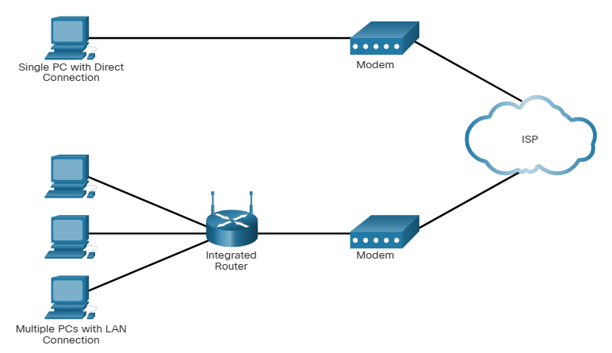

Top = simplest ISP connection consisting of modem and computer (its not used)

Bottom = same but with router that works as a switch and wireless connection

It provides also secure connection and provides IP address for the hosts

Cable and DSL connections

The most common ways to connect to their service are:

- cable:  
 - typically **offered by cable television service providers**,

**- Internet data is carried on the same coaxial cable that delivers cable television**

It provides High bandwidth, always on, connection to internet

- DSL - digital subscriber line:

Provides high bandwidth, always on, connection to the internet

Requires high speed modem that separates DSL signal from the telephone signal

**It runs over a telephone line, with line split into 3 channels**,   
 one channel is used for **voice telephone calls**  
 second channel is a **faster download channel** third channel is used for **sending or uploading information**

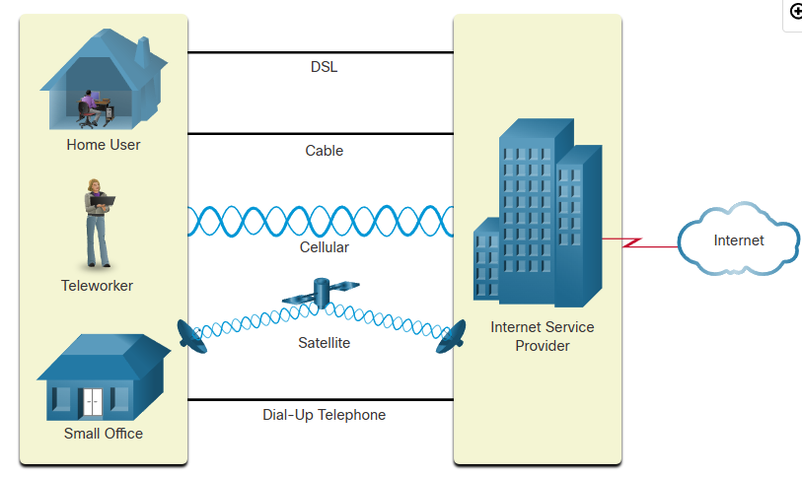

Additional connectivity options

Other ISP connections options for home users include:

Cellular

**It uses a cell phone network to connect**

Performance will be limited by the capabilities of the phone and cell tower

Satellite

It’s a good option for homes or offices that do not have access to DSL or cable

**It need clean line of sight to the sate-lite**

Speed will vary depending on the contract, but they are generally good  
 the access is the real benefit

Dial-up Telephone

**Inexpensive option that uses any phone line and a modem**

Its usually **not sufficient for large data transfer** butgood for mobile access while traveling

**It should be considered when higher speed connection are not available**